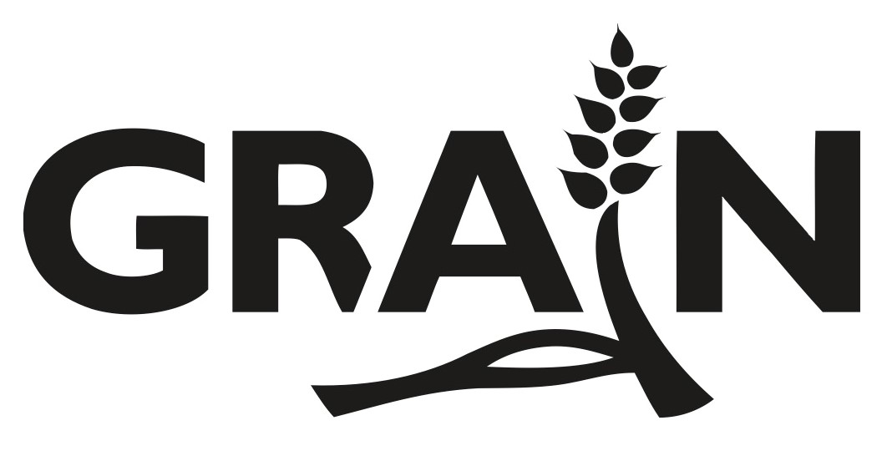

African Agriculture, Inc Fact Sheet
June 16, 2022

African Agriculture, Inc (AAGR) is a US-based holding company created in 2021. According to filings at the US Security and Exchange Commission, AAGR bought the Senhuile farm, now renamed Les Fermes de la Téranga (LFT), located in Senegal from its Italian owners for US$7.9 million in 2018. AAGR maintains that through this purchase it acquired the land use rights to the 20,000 hectares granted to Senhuile by the president of Senegal in 2012. Communities depending on this land for their livelihoods prior to 2012 claim the land was leased to the company against their will.

The concession has been granted for a period of 50 years (until 2062) and is considered by its new US corporate owners to be currently worth more than US$18 million. In addition, AAGR has acquired 5,000 hectares in nearby Fass Ngom under a 15-year lease dated June 2018, bringing the firm’s claimed total land holdings to 25,000 hectares in Senegal.

The main aim of AAGR is to grow alfalfa as livestock feed for the international market. It also plans to produce biomass for biofuel, grow trees to sell carbon credits and engage in fish farming.

AAGR is owned by Romanian mining and energy tycoon Frank Timis (80%) and Senhuile’s former chair Gora Seck (9%). US investor Alan Kessler serves as Chairman and CEO. In March 2022, the company initiated a public offering (IPO) on the Nasdaq stock exchange with the goal of raising US$40 million to finance its operations. If the listing goes ahead, Kessler will have the right to acquire 5% of the shares.

The company acknowledges many risks associated with its plans. These include the right of the president of Senegal to cancel the land rights it acquired without prior notice, as well as the possibility that the company is held responsible for generating greenhouse gas emissions by producing livestock feed. The company also recognises that it may lose access to the public water sources that its Senegalese farm relies on.

On May 30, 2022 AAGR received a letter from the Collectif pour la Défense du Ndiaël – representing 37 villages and over 10,000 people in Senegal – demanding the immediate return of their land, as well as adequate remediation and compensation for the harm and economic loss inflicted upon communities by ten years of occupation of their land by the project. In his response to the letter, Kessler ignored the communities’ demands and instead highlighted a number of actions by his company in their favour, including contributions for the celebration of Ramadan and Eid holidays and distribution of fodder to a few herders.

In their IPO filings, AAGR also indicated plans for a major carbon credit tree-planting project in Niger. They claim to have reached agreements with the local governments of Ingall and Aderbissinatt to lease over 2.2 million hectares of land for 49 years. AAGR also claim to have secured water usage rights for their Niger operations.

For more details, see the graph “Who is African Agriculture, Inc.?”.

See https://www.sec.gov/edgar/browse/?CIK=0001884334

